Steps to setup the RoboDK plug-in for SolidWorks:

These instructions temporary steps to setup the plugin. In our next release, the SolidWorks plugin will be installed by default with the RoboDK installer:
- Download and Unzip the following folder in C:/RoboDK/Other/Plugin-SolidWorks/:
https://robodk.com/downloads/plugins/SolidWorks-RoboDK-plugin.zip
- Right click the file RegAsm.exe and select Properties.
- Select “Unblock”.
- Repeat 2 and 3 for the two DLL files.
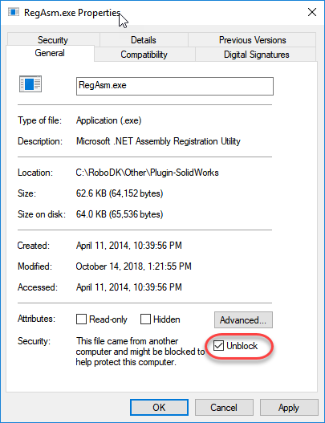
- Run the Plugin_Install_RunAsAdministrator.bat file as Administrator:
Right click the BAT file and select Run as Administrator.
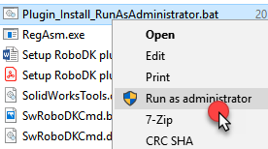
- Run the SolidWorks application and go to "Tools -> Addin" then we can find the "RoboDK Plug-In" Addin.
Important: Run the BAT file as Administrator.
Important: Don't change the location of the binaries after running the batch file once.
Important: Make sure to “rebuild” your assembly. There is a SolidWorks crash when using the Auto Setup option without updating the assembly.

